Harris Academy
  - 2024



Respect Equality Enjoyment Achievement

CHILD PROTECTION
  - A Policy on Child Protection - Review June 2025
Contents
Harris Academy Aims and Values 2
Dundee Protects 3
Introduction 4
The UNCRC (2024) 6
Aims of this Policy 8
Roles and Responsibilities 10
What to do if 11
Data Protection 13
Concerns Flowchart 14
Dealing with Disclosures of Abuse 15
Confidentiality 16
Ensuring Safe Professional Relationships 17
Appendix A………………………………………………………………………………… 18
Appendix B………………………………………………………………………………… 21
Appendix C………………………………………………………………………………… 22

Harris Academy Aims and Values
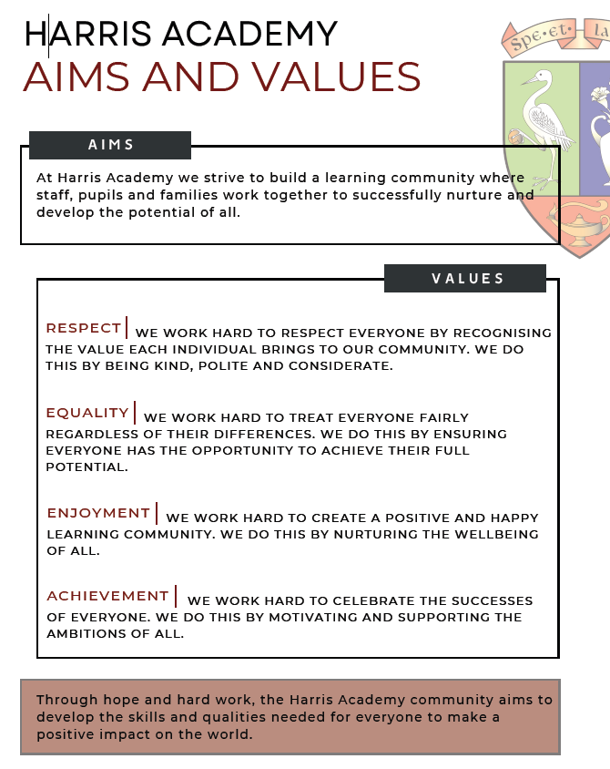

Dundee Protects

Child protection is important and it is essential that everyone understands the contribution they have to make in keeping all children and young people safe and protected from harm and abuse.

“… school staff… play a crucial role in the support and protection of children as well as the development of their wellbeing. …Teachers are likely to have the greatest level of day-to-day contact with children and so are well placed to observe physical and psychological changes in a child that could indicate abuse and to contribute to the assessment of vulnerable children”​
National Guidance for Child Protection in Scotland (2014)​
Introduction
These guidelines outline the responsibilities of all staff at Harris Academy in relation to protecting our young people. Harris Academy places great importance on empowering children and young people to understand their rights and know how to keep themselves safe by making informed decisions.

The policy will outline child protection processes within the school and the city which align closely with the National Guidance for Child Protection in Scotland 2021. The Children and Young People (Scotland) Act 2014 also sets out roles and responsibilities.

Under the National Guidance for Child Protection in Scotland 2021, all staff who work with young people have a responsibility to protect them and to safeguard their well-being. In the event of a concern being raised about a young person, all education personnel are expected to work closely with all other relevant agencies. Attentive listening and accurate recording is essential at all stages, from initial concern to disclosure, investigation and monitoring.

“All children and young people in Scotland have the right to be cared for and protected from harm and to grow up in a safe environment in which their rights and needs are respected. The welfare of children is paramount.”

“Every adult in Scotland has a role in ensuring all our children live safely and can reach their full potential.”

The Children and Young People (Scotland) Act 2014 places a specific duty on services to safeguard, support and promote the wellbeing of children and young people. It builds upon the principles set out in the Children (Scotland) Act 1995 which places a specific duty on Local Authorities to investigate if it believes that a child is or is likely to suffer significant harm.

Child protection is an important element of the wider Getting it Right for Every Child (GIRFEC) approach.
GIRFEC promotes action to improve the wellbeing of all children and young people in eight areas, known as Wellbeing Indicators. Children and young people must be safe, healthy, achieving, nurtured, active, respected, responsible and included. The primary indicator for child protection is to keep a child safe and, in so doing, attention is given to other areas of wellbeing as appropriate.

Child Protection processes use the key components of GIRFEC:

- a focus on improving outcomes for children, young people and their families based on a shared understanding of wellbeing;
- a common approach to gaining consent and sharing information where appropriate;
- an integral role for children, young people and families in assessment, planning and intervention;
- a co-ordinated and unified approach to identifying concerns, assessing needs, agreeing actions and outcomes, based on the wellbeing indicators
- streamlined planning, assessment and decision-making processes so that children, young people and their families getting the right help at the right time
- consistent high standards of co-operation, joint working and communication
- a key contact in universal services for each child and a Lead Professional to co-ordinate and monitor multi- agency activity where necessary
- maximising the skilled workforce within universal services to address needs and risks early

The term young person within these guidelines refers to all young people in educational provision under 18 years of age. The term parent means all persons deemed in law to have parental responsibilities for the child.

The UNCRC (2024)

The Convention has 54 articles that cover all aspects of a child’s life and sets out the civil, political, economic, social and cultural rights. The convention is universal —these rights apply to every child and the convention entitles every child to claim them. It also explains how adults and governments must work together to make sure all children can enjoy all their rights.
Every child has rights, without discrimination of any kind against the child, parent, or legal guardian (Article 2).
We should think of the Convention as a whole: each of the rights enshrined within it is interlinked, and no right is more important than another. The following rights are of equal importance to every child. Every child has the right to:
- Respected Views (Article 12)
- Be safe from violence (Article 19)
- An education (Article 28)
- Sufficient standard of living (Article 27)
- Know their rights (Article 42)

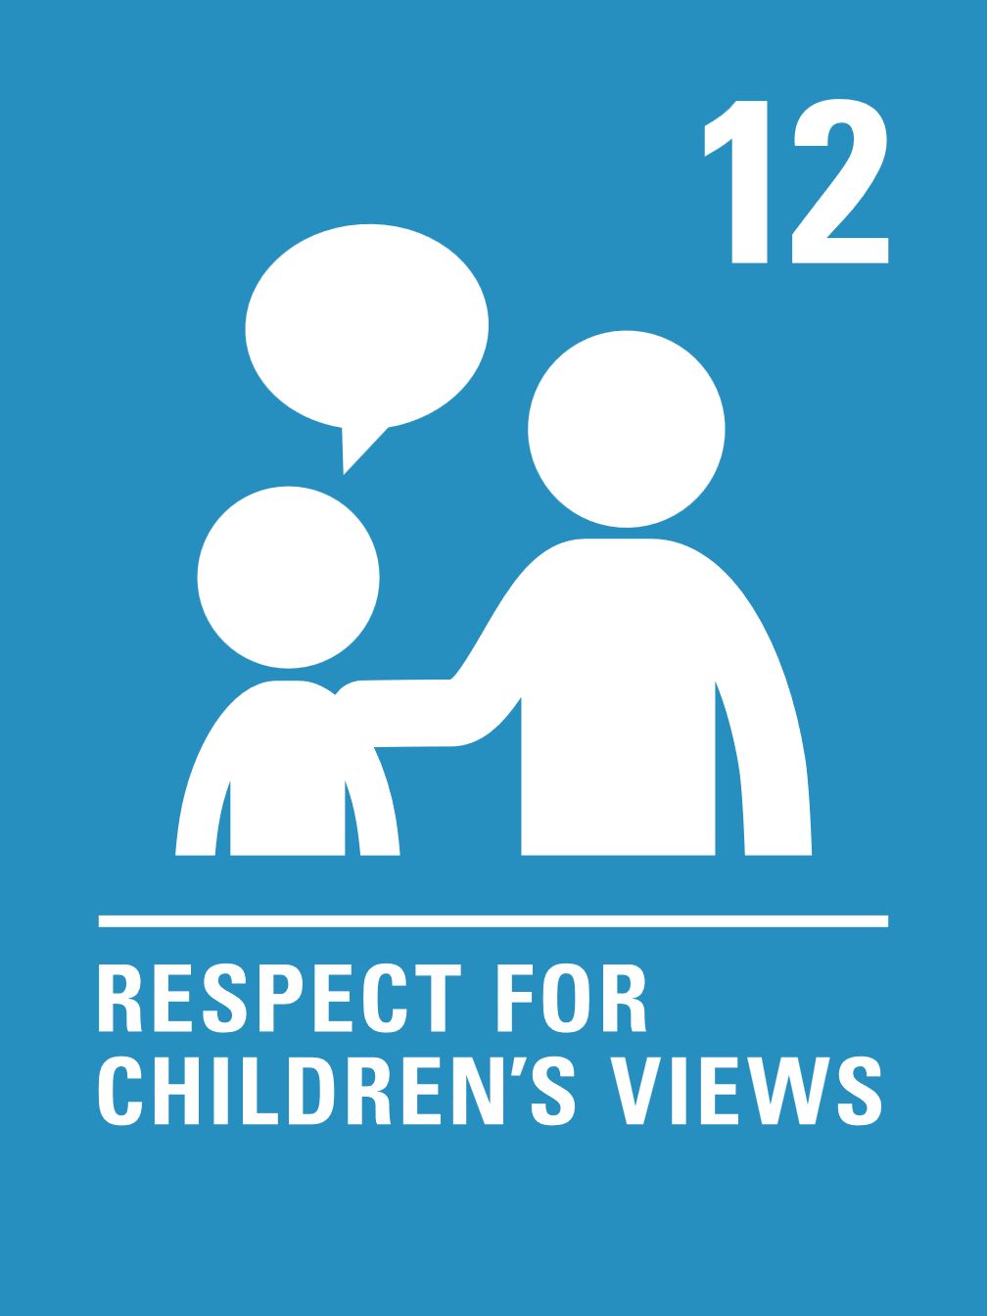
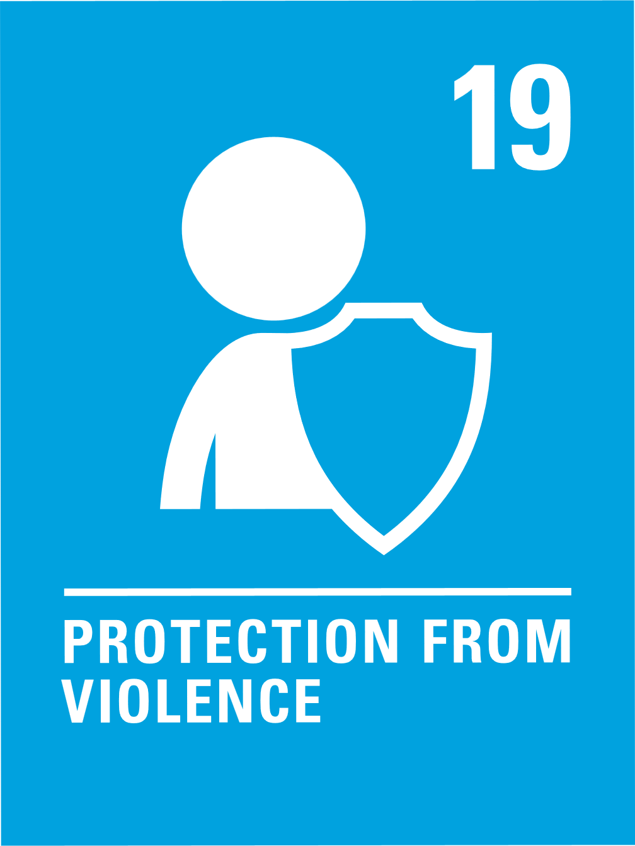
- Exploitation (Article 34)

Harris Academy has achieved the Silver Rights Respecting School award. We have proven that we are committed to upholding children’s rights and supporting them to access the skills, qualities and experiences they need to live a fruitful life in a 21st Century Scotland. We are presently working towards achieving the Gold Rights Respecting School Award.
We are proud of the work we have completed as a school in relation to becoming an accredited Rights Respecting School, including the development of our Rights Respecting Schools Charter where pupils, from across all year groups, have identified the nine rights our young people feel are most important to them.

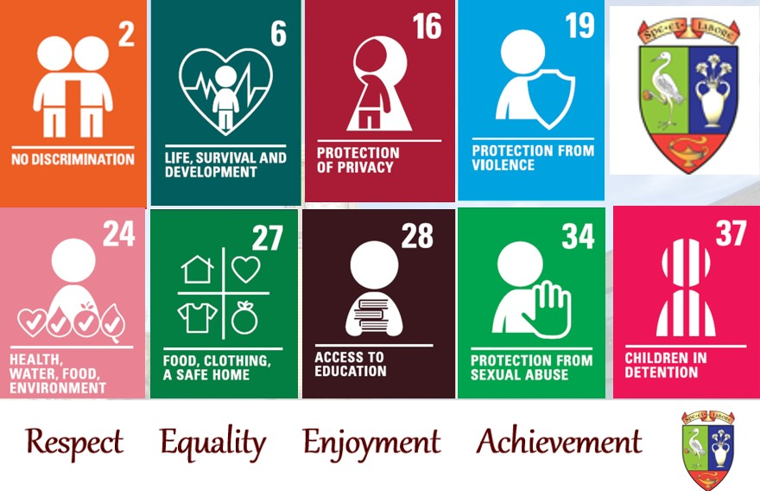

Aims of this Policy

We aim to:
- ensure that all staff within Harris Academy are aware of their responsibility to protect our young people from all forms of neglect, abuse and discrimination as far as is possible;

- ensure that all staff are aware of our child protection guidelines;

- ensure all child protection and safeguarding policies and procedures reflect current legislation and guidance;

- ensure that all staff are aware of the indicators of neglect and the different categories of abuse and are familiar with some common signs linked to the categories;

- ensure that all staff are aware of the steps taken once issues of neglect and child abuse is recognised or disclosed;

- ensure that our young people, through our health and wellbeing topics within Personal and Social Education, have experience of appropriate life and social skills to make them aware of how to resist or avoid abuse and how they can seek the support of the known adults within school;

- ensure that all parents/carers and young people are aware of and understand the child protection policy and the information which a variety of agencies hold and with whom they may be shared;

- ensure that all parents’ views are taken into account with regard to information sharing with or without their consent;

- ensure that all child protection reports contribute to the child’s assessment and any plan which will regularly be reviewed in order to ensure that it meets the child’s needs.

We will achieve these aims by:

- reviewing our policy annually to ensure all staff are aware of their responsibilities and any new legislation;

- ensuring that all school staff are briefed on local authority and school policy regarding child protection and have their knowledge updated and refreshed at the beginning of the school session in August;

- ensuring that all new staff will receive child protection training within their first term at Harris Academy;

- ensuring that all staff complete the online training which can be accessed through Dundee City Council E learning modules;

- ensuring that all members of staff have a copy of Harris Academy’s Child Protection Policy which outlines the categories of abuse and details the steps which an adult must take if child abuse is suspected or disclosed;

- ensuring that all members of staff have a copy of the name and photograph of the Child Protection Officers, Pupil Support Co-ordinator and Head Teacher;

- the name and photograph of the Child Protection Officers, Pupil Support Co-ordinator and and Head Teacher are displayed throughout the school;

- monitoring our Personal and Social Education programme to ensure appropriate life and social skills are being taught and that pupils are aware of how to resist or avoid abuse and how to approach the known adults in school;

- ensuring standard records are kept in a consistent manner and stored securely within school in line with the advice from Dundee City Council;

Roles and Reponsibilities

“All individuals working with children have a duty and responsibility to share any suspicions or concerns of a child protection nature, which come to their attention.”

All school staff and volunteers are well placed through pupil contact to observe physical and psychological changes in a child which might indicate abuse or need. Whilst the statutory responsibility for investigating cases of child abuse rests with social work and the police, teachers and other school staff have a real responsibility in identifying, monitoring and reporting possible cases of emotional, physical and sexual abuse as well as other support needs of a child. Definitions of the categories of abuse can be found in Appendix A.

It is essential to maintain strict confidentiality in all child protection matters. You have a duty to pass on your concerns but should not discuss the concerns with anyone who is not relevant to the enquiry. Breach of confidentiality is a serious disciplinary matter and will be reported to the Headteacher in the first instance. All staff should be aware of their role in any child protection matter. Every child’s opinion should be listened to and valued. Advice on listening to the child can be found in Appendix B.

What to do if you have a Concern, Suspicion or Receive a Disclosure about a Child

Everyone within the school has a responsibility to identify and pass on concerns, suspicions or disclosures they receive about a child to the school’s Child Protection Officer who will listen carefully to your concern. Guidance for dealing with any concerns, suspicions or disclosures are summarised here and illustrated in the flow chart at the end of this section:
- If a member of staff has a concern, suspicion or received a disclosure about a young person, it is crucial that the above summary is followed in conjunction with the advice given below;

- In all cases, the facts as known should be recorded on the Child Protection Concern Form, CP1, (Appendix C) of this policy and forwarded immediately, in person, to the Child Protection Officer;

- Members of staff must not ask leading questions when dealing with concerns, suspicions or disclosures (Appendix B);

- A full inquiry or investigation by a single member of staff must be avoided because collection of evidence is a specialist police/social work role. Inappropriate inquiries may prevent successful prosecution;

- In all cases when passing your concerns to the Child Protection Officer, you should keep a written log of all incidents/events on the Child Protection Concern Form (Appendix C), for recording in the child’s chronology. It is important that this log is completed with times and dates noted. The report must be forwarded immediately to the Child Protection Officer who in turn will ensure a copy is placed in MOSAIC;

- If the Child Protection Officer is not available then concerns should be passed to the Depute Head Teacher who will fulfil the function of the Child Protection Officer in his/her absence;

- If neither the Child Protection Officer or the Pupil Support Co-ordinator are available then concerns should be passed to the Headteacher who will fulfil the function of the Child Protection Officer in his/her absence;

- In the unlikely event that no member of the Senior Leadership Team are available, then concerns should be shared with the named person for the child. In Harris Academy the named person is the Principal Teacher of Guidance for the young person;

- The Child Protection Officer may contact any agency who may have information about the young person or family and discuss concerns and relevant information about the young person and their circumstances in the child’s best interests;

- If the Child Protection Officer believes that there is sufficient concern of neglect or abuse, they will contact the Multi Agency Support Hub (MASH). A call to MASH is made and then recorded on MOSAIC. Initial contact with MASH should always be by telephone. This must then be followed up by recording the relevant information and any advice on the Child Protection Workflow on Mosaic. There are four possible outcomes from this contact: a child protection investigation; further information gathering by MASH; the convening of a TATC meeting by the school; and monitoring by the school. Any further information around this particular concern can be added to this workflow or in a Mosaic Casenote.
If you have significant concerns that a child is in immediate danger and neither the Child Protection Officer, the Pupil Support Co-ordinator and Head Teacher, members of the Senior Leadership Team or the named person are available, please contact MASH 01382 307940 for advice and guidance. Do not delay in contacting MASH because you cannot contact the Child Protection Officer, the Pupil Support Co-ordinator, Senior Leadership Team or named person - a child’s safety may be at risk.

Remember:
If you hear, see or read anything that causes you to become concerned about a child or young person’s safety, talk to a Designated Child Protection Officer about it immediately. Do not hold on to information that worries you. No-one will criticise you if it turns out that there is no child protection concern. Acting now could save a child or young person from further harm.

Data Protection

The management and protection of information and the obligation to provide information is set out legally in the Data Protection Act 1998, the Freedom of Information (Scotland) Act 2002 and the General Data Protection Regulation 2016. Individuals have a right of access to information about them and can make an access request for all information held on them. A parent can make a request on behalf of their child. The service is also required to describe the purpose for which information is held and to whom it is disclosed.

Concerns Flowchart
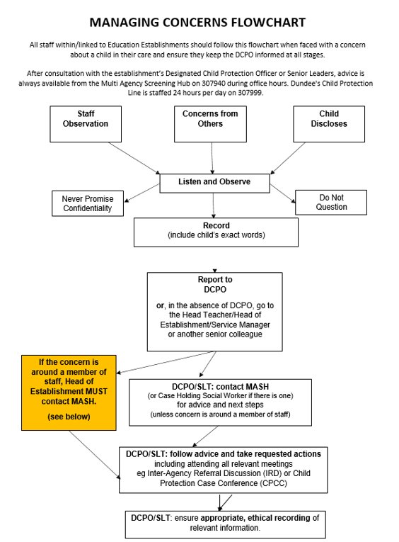

Dealing with Disclosures of Abuse – Advice for Staff
Children who are being abused or neglected are dependent on others, usually adults, to help them. Next to parents, school staff are those professionals who see children most often. As such, adults in Harris Academy are well placed to be seen by a young person as a trusted adult to whom they can discuss concerns/worries with. This may cause apprehension for staff about how to deal with disclosures of abuse but all staff members have a duty of care. Adults in educational establishments have a relationship with the child which is trusting, hence young people choose to disclose. These adults also have knowledge of the child / young person’s cognitive ability, emotional wellbeing and some idea of the home situation and so are well placed and skilled to deal with disclosure.

General responses:
- Don’t panic - the main skill required is listening.
- Never promise confidentiality.
- Always listen attentively.
- Don’t make promises you cannot keep. Usually, everything isn’t ‘fine’ once a disclosure is made, at least initially. Things may get worse before they get better.
- Take the disclosure seriously (many young people fear they won’t be believed)
- Be aware of non-verbal messages you are giving out (Children will pick up on any reaction of yours eg. shock, and in order to protect you, may stop talking)
- Do not show disbelief, no matter what the child discloses. It is important that you take all that you are told seriously
- Reassure the child that disclosing is the right thing to do.
- Be open and non-judgmental.
- Where you have a question ensure it is "open", not closed or leading.

Specific responses:
- Establish the child's level of understanding;
- Avoid a "who dunnit" approach and only ask enough to gain the basic information - the pursuit of evidence is a matter for forensic interview and a component of formal investigation.
- Affirm the young person’s feelings i.e. It is okay to be angry, anxious or sad.
- Do not dwell on the identity of any alleged perpetrator and avoid being critical of the alleged perpetrator. Regardless of the abuse, the child / young person may love this person.
- Take advice / support from your designated child protection officer at all times
- Record, in the child’s words, as far as possible, what the child said (If obvious bruising, describe, as accurately as possible, where it is, old or new bruise, size and shape). Write up and date the recording, after the disclosure to ensure it is accurate.

Confidentiality

When a child or young person is at risk of abuse or neglect, confidentiality is not an option. Information must be shared with the Child Protection Officer or Pupil Support Co-ordinator.

Legislation informs us that a child has a right to confidentiality but that is qualified and never absolute. In cases where a young person discloses information about themselves to education staff or to a third party which could constitute significant harm, then it should be made clear to them that confidentiality, if that is what they request, cannot be guaranteed. It is necessary to be honest and to explain to any child that professional adults in the educational context are required to share certain information to protect them and others from harm.

Ensuring Safe Professional Relationships with Young People – Safe Practice Advice

- When alone with a child, always inform other staff where you are and what you are doing
- Maintain a physical gap or barrier between you and a child, where possible
- If you see a member of staff behave inappropriately (e.g. humiliating, screaming, pulling, pushing or hitting) towards a child, you must share this with the Head Teacher
- If you are aware of a child being attracted to you, you must share your concerns with your link Senior Leadership Team member immediately
- Avoid any inappropriate physical contact with a child or any other interaction which may lead to your professional motivation being questioned
- Ensure any contact you have with a child is age and stage appropriate
- Always behave professionally

- Ensure any social media or other online presence you have does not leave you open to criticism and professionally vulnerable, particularly where young people may get access to information you have created or posted. Ensure that you follow GTCS Professional Guidance on the use of Electronic Devices.

Appendix A

Definitions of the categories of Child Abuse

Child abuse is the term used to describe ways in which children are harmed, usually by adults and often by people they know and trust. It knows no geographical or social boundaries. All forms of child abuse involve the elements of a power imbalance, exploitation and the absence of true consent.

Categories of Child Abuse:

- Physical Injury – actual or attempted physical injury including the administration of toxic substances.
- Physical Neglect - child denied , sleep, clothing, cleanliness, shelter, warmth. Left unattended or inadequately supervised.
- Sexual Abuse– when any person by design or by neglect causes the child to be involved in any activity that might lead to sexual arousal or gratification including organised networks. This includes rape, intercourse and lewd and libidinous practices
- Emotional Abuse/ Emotional Neglect – coldness, hostility, criticism, inappropriate punishments, isolation, scapegoating. Wilful destruction of a child’s confidence.
- Non-Organic Failure to Thrive/ Neglect – failure to meet expected weight and growth norms or developmental milestones, malnutrition, lack of nurturing and stimulation. This occurs when a child’s essential needs are not met and this is likely to cause impairment to physical health and development. Such needs include food, clothing, cleanliness, shelter and warmth. A lack of appropriate care results in persistent or severe exposure, through negligence, to circumstances which endanger the child. Physical neglect may also include a failure to secure appropriate medical treatment for the child, or when an adult carer persistently pursues, or allows the child to follow, a lifestyle inappropriate to the child’s developmental needs or which jeopardises the child’s health.

This category also covers children who are left on their own for long periods and do not receive enough stimulation or suffer sensory deprivation, especially in infancy. They may also not experience enough nurturing, nor have many caregivers. Severe neglect of young children is associated with major detrimental effects on growth and intellectual development. Constant neglect can lead to health and long-term developmental problems socially, emotionally and educationally. Neglect in some cases can result in physical disability and deformity and even death. In its chronic form, non-organic failure to thrive can result in the child suffering more serious illnesses, a reduced potential height and, with young children particularly, the results may be life-threatening over a relatively short period.

Vulnerability Factors – issues which can affect the wellbeing and safety of children:

Children may need our support or help but not be victims of child abuse. Children may need our support through difficulties at certain times in their lives e.g. divorce, new partners in the home, new families, bereavement suicide, moving home, moving school, adoption, fostering etc.

The Children’s Hearing (Scotland) Act 2011 introduced new grounds for referral and these should also be considered when thinking about children who may be in need of support, these grounds include;

The child has, or is likely to have, a close connection with a person who has carried out domestic abuse

The child has, or is likely to have, a close connection with a person who has committed a schedule 1 offence.

The child has misused alcohol.
- The child has misused a drug (whether or not a controlled drug).
- The child is being, or is likely to be, subjected to physical, emotional or other pressure to enter into a marriage or civil partnership, or is likely to become a member of the same household as such a child.

For the purpose of this policy “a close connection”, would mean that the child is a member of the same household as the person or the person is not living in the same household but the child has significant contact with them. Difficulties such as these should be reported in the same way as you would report concerns re child abuse as they are still child protection issues and may require adjustments to the curriculum or input from other agencies

Additional Factors / Risk Indicators
The following factors should act as a prompt for all staff working in an adult or childcare setting, to consider how they may impact on a child. Where these co-exist, risk may be increased
- Domestic Abuse
- Parental alcohol misuse
- Parental drug misuse
- Children or Young People experiencing or affected by disability
- Children and young people experiencing or affected by mental health problems
- Children and young people who display harmful or problematic sexual behaviour
- Non engaging families
- Sudden unexpected death in infants and children

Harm outside the home

- Child Trafficking
- Child Exploitation
- Online and Mobile phone child safety
- Children and young people who place themselves at risk
- Underage sexual activity
- Forced Marriage
- Concealed pregnancy
- Female Genital Mutilation (FGM)
- Radicalisation
Difficulties such as these should be reported in the same way as you would report concerns re child abuse as they are still child protection issues and may require adjustments to the curriculum or input from other agencies.

Appendix B

Listening to the Young Person

The first steps when listening to a young person are crucial. They often feel frightened, confused and vulnerable.

Be receptive.

Take it seriously – there is a reason for the child imparting such information.

Reassure the child they are right to tell, listen carefully, avoid showing any kind of shock reaction.

Make no promises about keeping it confidential or not telling anybody.

Tell the young person you need to seek help.

Make a careful record of what was said – use the child’s words not your own. In all cases, record the facts as known on the Child Protection Concern Form (Appendix C) of this policy for forwarding, in person, to the Child Protection Officer.

Don’t jump to conclusions, speculate or accuse anyone.

Don’t use or ask leading questions: this is not your role. A full inquiry or investigation by a single member of staff or volunteer worker must be avoided because collection of evidence is a specialist police / social work role. Inappropriate inquiries may prevent successful prosecution.

Inform the Child Protection Officer, Pupil Support Co-ordinator, Head Teacher or failing that, another member of the SLT, failing that, the named person for the child and, failing that contact MASH yourself - a child’s safety may be at risk.

.

Appendix C

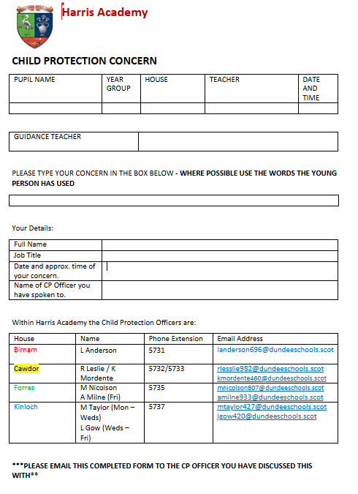
Our CP 1 form can be accessed in Teams as outlined below and via the hyperlink:-

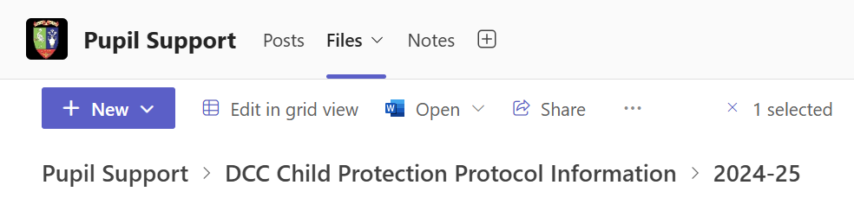

PUPIL CP FORM August 2024.docx

